**ADDING A DATAFILE TO A TABLESPACE**

**Before Automation**

1. **Check the freespace in server.**

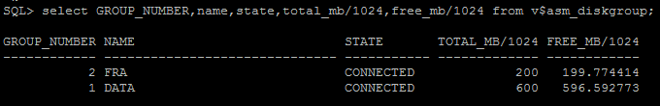

1. **Check the tablespace details,**



1. **Add one datafile into the tablespace manually by using the below query,**

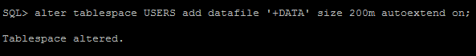

1. **Check the tablespace detail again**

**Before Automation**

1. **Dispalying the diskgroups free and available space**

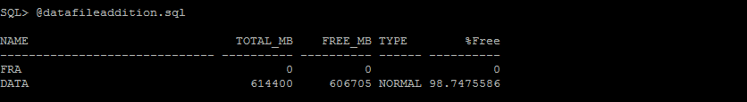

1. **Dispalying the tablespace details**

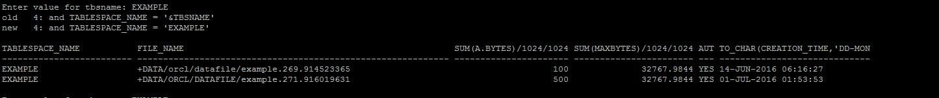

1. **Adding datafile to tablespace**



1. **Displaying the diskgroup free space and newly added datafile to tablespace.**



